 |  | INTERNATIONAL TELECOMMUNICATION UNION
 |  | ITU-T | G.984.3
 |  | TELECOMMUNICATION  STANDARDIZATION SECTOR  OF ITU |  | Amendment 2  (03/2006)
SERIES G: TRANSMISSION SYSTEMS AND MEDIA, DIGITAL SYSTEMS AND NETWORKS
Digital sections and digital line system – Optical line systems for local and access networks

Gigabit-capable Passive Optical Networks (G-PON): Transmission Convergence Layer Specification
Amendment 2
CAUTION !
PREPUBLISHED RECOMMENDATION
This prepublication is an unedited version of a recently approved Recommendation. It will be replaced by the published version after editing. Therefore, there will be differences between this prepublication and the published version.

FOREWORD
The International Telecommunication Union (ITU) is the United Nations specialized agency in the field of telecommunications. The ITU Telecommunication Standardization Sector (ITU-T) is a permanent organ of ITU. ITU-T is responsible for studying technical, operating and tariff questions and issuing Recommendations on them with a view to standardizing telecommunications on a worldwide basis.
The World Telecommunication Standardization Assembly (WTSA), which meets every four years, establishes the topics for study by the ITU-T study groups which, in turn, produce Recommendations on these topics.
The approval of ITU-T Recommendations is covered by the procedure laid down in WTSA Resolution 1.
In some areas of information technology which fall within ITU-T's purview, the necessary standards are prepared on a collaborative basis with ISO and IEC.

NOTE
In this Recommendation, the expression "Administration" is used for conciseness to indicate both a telecommunication administration and a recognized operating agency.
Compliance with this Recommendation is voluntary. However, the Recommendation may contain certain mandatory provisions (to ensure e.g. interoperability or applicability) and compliance with the Recommendation is achieved when all of these mandatory provisions are met. The words "shall" or some other obligatory language such as "must" and the negative equivalents are used to express requirements. The use of such words does not suggest that compliance with the Recommendation is required of any party.

INTELLECTUAL PROPERTY RIGHTS
ITU draws attention to the possibility that the practice or implementation of this Recommendation may involve the use of a claimed Intellectual Property Right. ITU takes no position concerning the evidence, validity or applicability of claimed Intellectual Property Rights, whether asserted by ITU members or others outside of the Recommendation development process.
As of the date of approval of this Recommendation, ITU [had/had not] received notice of intellectual property, protected by patents, which may be required to implement this Recommendation. However, implementors are cautioned that this may not represent the latest information and are therefore strongly urged to consult the TSB patent database.

© ITU 2006
All rights reserved. No part of this publication may be reproduced, by any means whatsoever, without the prior written permission of ITU.
Amendment 2 to ITU-T Recommendation G.984.3
Gigabit-capable Passive Optical Networks (G-PON) : Transmission Convergence Layer Specification
Summary
This amendment contains an informative appendix addition to G.984.3 concerning techniques to condition the data patterns in the downstream signal, as well as several minor corrections to the main body text.
Keywords
G-PON, Optical

Introduction
This amendment includes two informative improvements to the G-PON TC-layer specification, and several minor corrections to the main body text. The first improvement involves sending dummy packets or cells from the OLT whose payload is designed to control the pattern of ones and zeroes on the line to reduce harmful optical effects. The second improvement is the application of AES to all unicast downstream traffic to prevent a user from intentionally disrupting the PON.

Modifications to Recommendation G.984.3

Section 8.1.3.4
Replace the text in the section with the following.
“The BIP field is an 8-bit field that contains the bit-interleaved parity of all bytes transmitted since the last BIP excluding FEC parity (if present). The receiver shall compute the bit interleaved parity on all bytes received since the last BIP excluding the FEC parity (if present) and after FEC correction has been applied (if supported), and compare its result to the BIP transmitted in order to measure the number of errors on the link.”

Section 8.1.3.6.5
Add the following sentence to the end of the section.
“In addition, the ONU should handle errored or incorrect BWmap entries in such a way as to minimize the probability of collisions on the PON upstream. This in general means suppressing transmission for dubious allocations.”

Section 8.2
Append the following text to the second sentence of the last paragraph of the section, such that it reads as follows.
“The StopTime pointer must always be larger than the associated StartTime pointer, in that the smallest usable allocation is 2 bytes, which would be for a DBRu-only transmission.”

Section 8.2.2.1
Replace the text in the section with the following.
“The BIP field is an 8-bit field that contains the bit interleaved parity (exclusive OR) of all bytes transmitted since the last BIP (not including the last BIP) from this ONU, excluding the preamble and delimiter bytes, and FEC parity bytes (if present). The OLT receiver shall compute the bit-interleaved parity for each ONU burst excluding the FEC parity (if present) and after FEC correction has been applied (if supported), and compare its result to the received BIP field in order to measure the number of errors on the link.”

Section 8.3.2
Modify the sentence that reads:
“In the hunt state, the receiver searches for a GEM header HEC in all alignments (bit and byte).”
Such that it now reads:
“In the hunt state, the receiver searches for a GEM header HEC byte-by-byte (as the byte alignment is already provided by the GTC framing).”

Section 9.2.3.7 and Section 9.2.3.14
Add note to end of both sections.
“Note: A maximum of one OMCI connection (either ATM or GEM, not both) can ever be configured to any ONU. If the OLT attempts to configure a second OMCI connection, the ONU should implicitly assume that the first connection is deactivated.”

Section 12.2
Add the following paragraph to the end of the section.
“Note that the downstream encryption processing step is applied before FEC. However, the crypto-counter is derived from the frame as-transmitted, so the crypto-counter continues to run through the FEC parity bytes. The scrambling processing step is applied last.”

Section 13.2.1.1
Add the following sentence to the end of the section.
“Note that the FEC encoding processing step is applied before scrambling.”

Section 13.3.1.1
In the first paragraph of the section, delete the text “(original transmission)”.
Add the following sentence to the end of the section.
“Note that the FEC encoding processing step is applied before scrambling.”

Additions to Recommendation G.984.3

3.1 Appendix V
Add the following appendix
Appendix V
Downstream line data pattern conditioning
This Appendix describes two methods to control the downstream line pattern that are backward compatible and optional. The first improvement involves sending dummy packets or cells from the OLT whose payload is designed to control the pattern of ones and zeroes on the line to reduce harmful optical effects. The second improvement is the application of AES to all unicast downstream traffic to prevent a user from intentionally disrupting the PON.

V.1 Idle pattern control.
The basic concept of this technique is for the OLT to send dummy packets or cells during periods of low system utilization. The dummy packets have the characteristics that they have a Port-ID or VPI that is not used by any ONU or service, and that their payload is devised such that a desired pattern is impressed on the downstream line signal.
The size of the dummy packets is an arbitrary choice of implementation. (Of course, the dummy cell payload will be 48 bytes in length.) However, to make the system efficient in both data transport and pattern control, it is advised that the size of the dummy payload range from 48 to 64 bytes. This will make the fraction of controlled line signal be greater than 90% in the absence of real data, and it will occupy the line for no longer than 0.23 microseconds.
The Port-ID or VPI used for the dummy packets or cells is also an arbitrary choice of implementation. Because the OLT has complete control over the Port-ID / VPI address space, it is entirely up to the OLT to choose the ‘dummy address’.
There are two implementation methods described in this Appendix for determining the contents of the payload for these dummy packets/cells: 1) choose payload that is independent of the scrambler phase and 2) choose payload that is dependent on the scrambler phase.

V.1.1 Scrambler phase-independent payload
This method chooses the dummy packet/cell payload without knowledge of the scrambler phase. In this method, the payload can either be fixed or random. If the payload is fixed, then the fixed payload should be chosen such that it minimizes the peak value of any discrete spectral lines produced after scrambling. There are at least two methods for generating random payload: 1) using a long free-running PN generator (e.g. 2⁴³-1), or 2) filling the payload with AES encrypted data.
Figure V.1/G.984.3 illustrates the operation of this idle pattern control scheme. The blue curve shows the spectrum resulting from the exclusive-or of the repeating 5-byte pattern 0xB6AB31E055 (the GEM idle header) with the 127-bit scrambler sequence with a bit rate of 2.488 Gbit/s. The green curve shows the spectrum resulting from the exclusive-or of the repeating 53-byte pattern: 0xB5AB 31EA F3C5 EEC0 5212 677E E7E0 CB22 1A12 99E0 F997 26A8 4111 ACB3 86B8 B96E 3724 6C7B 0B70 0505 95CE 5452 8103 BF00 7905 98C3 DA with the 127-bit scrambler sequence with a bit rate of 2.488 Gbit/s, resulting in a 10 dB reduction in the peak relative to the GEM idle header. The red curve shows the spectrum resulting from the exclusive-or of a repeating 53-byte random payload with the 127-bit scrambler sequence with a bit rate of 2.488 Gbit/s, resulting in a 13.7 dB reduction in the peak relative to the GEM idle header.
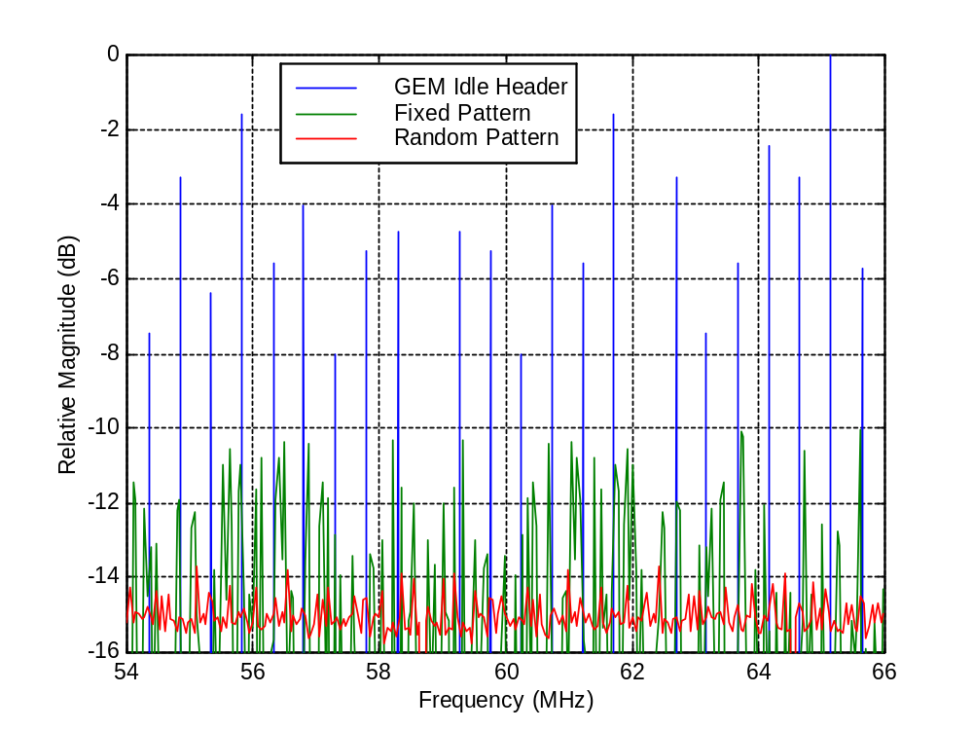
Figure V.1/G.984.3 - Spectrum after scrambling of the GEM idle header (blue), fixed 53-byte pattern (green), and random 53-byte pattern (red)

V.1.2 Scrambler phase-dependent payload
The scrambler phase-dependent payload pattern design is composed of two aspects. The first aspect is the design of the pattern that is desired to appear on the line. The desired pattern should be selected to have favourable spectral or temporal characteristics. One particular desired pattern is described below, but there are literally an unlimited number of patterns that could be used. The second aspect is the management of the downstream scrambler. The scrambler will XOR with the payload (and header) of all frames from the OLT, and thereby randomize the pattern on the line. To reverse this, the OLT must XOR the desired pattern with the scrambler pattern before the dummy packets / cells are scrambled. The OLT equipment must take care to use the scrambler pattern that is in exact bit alignment with the line scrambler.
On the subject of selecting a desirable pattern, there are several characteristics of the line signal that can be of interest. One of these is the presence of repeating patterns that can produce frequency harmonics in the line signal. These harmonics can then leak into other signals (e.g., the video overlay) via Stimulated Raman Scattering (SRS), thereby causing crosstalk. Another characteristic is the overall spectrum of the line signal. Ordinary scrambled NRZ coding produces a spectrum that is weighted towards the low frequencies, as shown in Figure V.2. These low frequencies have enhanced nonlinear fibre crosstalk associated with them.
In view of these characteristics, a favourable desired pattern is one that has a very long repeat length, and that has frequency spectrum that is shifted toward higher frequencies. A simple pattern with these properties is a pseudo-random Manchester coded sequence. The pseudo-random generator can be selected to have a primitive high-order polynomial (e.g., 2^43-1), and is configured to operate at half the bit rate of the downstream signal. Then, each pseudo-random digit is encoded as a Manchester code symbol (01 or 10). The resulting pattern will have a spectrum as shown in Figure V.2, illustrated for the case of 2.488 Gbit/s downstream transmission.
One must keep in mind that the idle pattern control is only effective for the fraction of time that the downstream G-PON system is idle. To illustrate this, let’s suppose that the system is operating at approximately 25% occupancy, and that the dummy packet payloads are created to be 48 bytes long. In this case, the desired pattern appears on the line approximately 67% of the time. Therefore, the spectrum of the line signal will be the weighted average of the scrambled and Manchester coded spectra. The average reduction in spectral intensity is then as shown in Figure V.2. In the important 50~100 MHz region, the reduction is around 4 dB in this example. This would produce a 3dB improvement in Raman impairments for overlay signals on the PON. It should be noted that higher downstream utilization will produce less improvement, and vice-versa.
0.00
0.20
0.40
0.60
0.80
1.00
1.20
0
622
1244
1866
2488
Frequency (MHz)
Spectral Intensity
-6.0
-4.0
-2.0
0.0
2.0
4.0
6.0
Raman Reduction (dB)
Scrambled Code
Manchester Code
Averaged Code
Averaged Reduction
Figure V.2/G.984.3 - Spectra of ordinary scrambled pattern, Manchester-coded pattern, the average code, and the average reduction in spectral intensity.

V.2 Intentional PON disruption
Because the scrambler sequence in this Recommendation is relatively short (127 bits), it is possible that a user could intentionally disrupt the PON by downloading packets filled with the scrambler sequence. This could lead to excessive consecutive identical digits being transmitted, which will likely result in the ONU receivers losing synchronization. To prevent this possibility, it is recommended that AES be activated on all point-to-point connections on the PON.
__________

